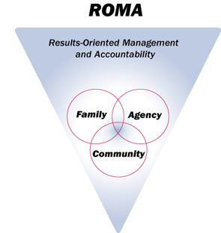

Training and Presenter Evaluation
Training Session Title: | Presenters:
Location: |  | Date/Time:

Please place an [ X ] in the appropriate box for your answer.
 | Strongly Agree | Agree | Disagree | Strongly Disagree
Training overall:
The training course was easy to understand.
The topics were covered in sufficient detail.
I would recommend this training course to others.
The information was presented in a way that honored my learning style and culture.
I was able to follow the course materials.
I can apply this information to the diversity of the families and communities I serve.
Overall this was a successful training course.
 | Strongly Agree | Agree | Disagree | Strongly Disagree
Presenters:
The presenters provided me with relevant information.
The presenters responded appropriately to questions.
The presenters were prepared.
The presenters were knowledgeable of the subject matter.
The presenters were effective in conveying the training objectives.

4428 Louisburg Road, Suite 101

Page

1

Summary Comments:
What new information did you learn from this presentation?
•
•
•
•
What are the next steps you plan to take to incorporate this at your agency?
•
•
•
•
What would you like more information on?
•
•
•
•
Please provide presenters with suggestions to improve future presentations.
•
•
•

4428 Louisburg Road, Suite 101

Page

2

